**Results For Mysore**

**LDA Topic Clouds :**

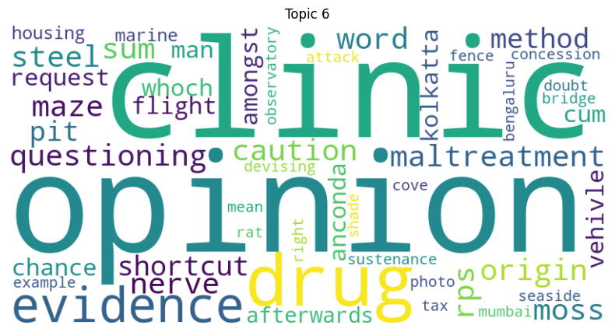

BERT

Optimal Number of Clusters: 2

Optimal Silhouette Score: 0.16323848068714142

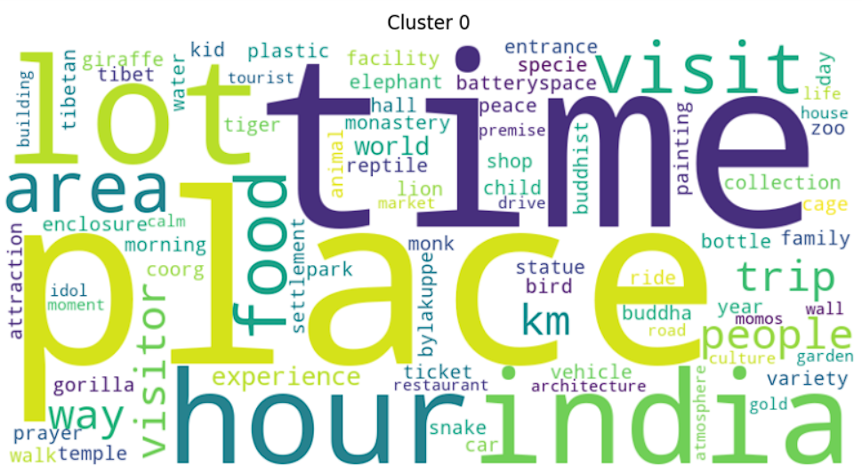

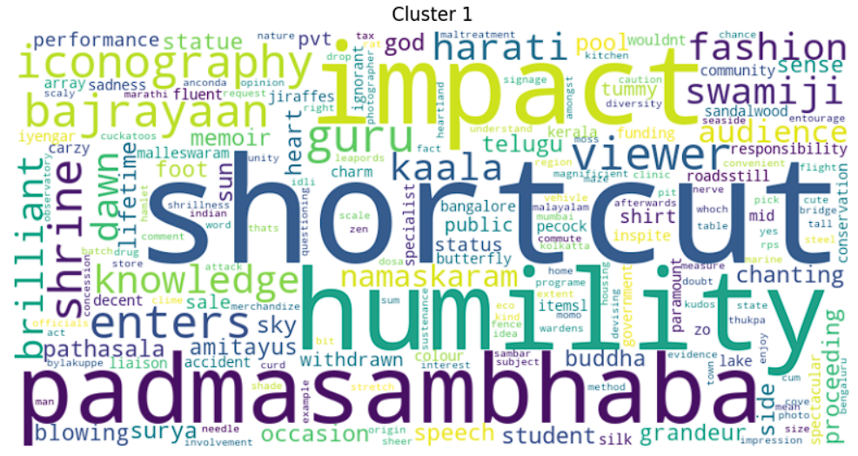

GPT-2

Optimal Number of Clusters: 3

Optimal Silhouette Score: 0.4579937756061554

